Appointment Types to Offer on Everseat

Appointment information appears on Everseat with customizable appointment type and notes:
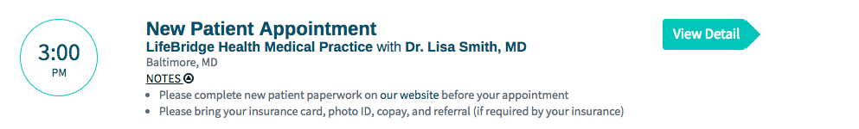

For each type of appointment you would like to offer, specify a name, notes, duration, and expiration time in the table below. Patients do not see the duration, only your staff can see the duration. Expiration is the time at which the appointment is no longer available or the lead time before the appointment starts. For example, a noon appointment with an expiration of 1 hour cannot be booked after 11 am, an hour before, the appointment time.

Appointment Type/Name in Everseat  (What Patient with see) | Appointment Type in PM System | Notes | Duration | Expiration
eg. Follow up | eg. Follow Up | eg. Please bring your insurance card and photo ID.
eg. Urgent | eg. Emergency | eg. This appointment is for existing patients who have an urgent issue.
eg. New Patient | eg. New Patient | eg. Please arrive 15 minutes early.

During the booking process, patients will enter their demographic information and any custom questions you set up. You can set up to 5 questions for the practice. Patients will see these questions, regardless of which appointment type they are booking. Each can be short free text answer, long free text answer, multiple choice single select, multiple choice multi select.
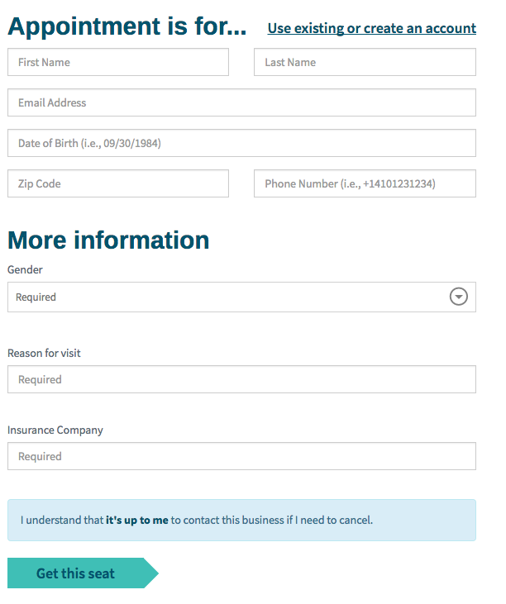

Question | Type | Multiple Choice Options | Required? Y/N
eg. Reason for visit | eg. short free text answer | eg. n/a | eg. Y
1.
2.
3.
4.
5.

